
Leadership, Empowerment, and Advocacy Fund (LEAF) Scholarships

LEAF Scholarships
LEAF Scholarships help individuals with disabilities and their family members go to conferences and trainings on disability topics.

Eligibility Requirements
- You must live in Pennsylvania, AND be at least one of the following:
- Individual with a developmental disability
- Family member or guardian of an individual with a developmental disability
- If offered, you must apply for scholarships or stipends from the event. The PADDC will only award LEAF funds if:
  - You are not given a scholarship or stipend through the event
  - There are extra costs after the scholarship or stipend.

The PADDC will help you attend events on these types of topics:
- Advocacy
- Leadership
- Self-determination
- Disability
- Disability rights
- Community organizing
- Accessing services
- Support and other assistance
- Council goals outlined in the State Plan
Funding will be prioritized for individuals who have not received funds in the past and for events hosted in Pennsylvania.
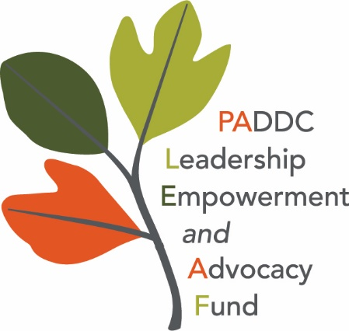
LEAF scholarships are up to $750 per person, per year. Unless the PADDC Executive Committee grants an exception, you must arrange and pay for all expenses. After you go to the event, you then submit your receipts. We can pay to cover the following costs:
  - Registration
  - Travel and lodging
  - Food
  - Rental of assistive equipment

Application Instructions
You must do the 2 steps below to apply for the LEAF scholarship:
- Complete the LEAF Application and Pre-event Questions found at this link: LEAF Application & Pre-Event Questions

- Email the following documents to ra-pwpaddc@pa.gov:
- Your application and pre-event questions form.
- Proof of the event you want to go to. For example, a brochure, agenda, fees, etc.
- A denial letter (if the event offered scholarships or stipends.)

Travel and Reimbursement Eligibility Requirements
We can pay for the following:
- A hotel only if the event is more than 50 miles from your home.
- A hotel at the government approved rate at the time of the event.
- Milage, at the government approved rate at the time of the event.
- Train or airfare cost (coach class only).
- Up to $30 per day for meals - IF the event does not provide meals, AND only if you have an overnight hotel stay.
- Receipts (taxi, tolls, parking, food, etc.) must include detailed information:
  - Name, address and telephone number of merchant
  - Date and time of purchase
  - Item and cost of item

Requirements Following Event
You must complete and submit the following documents within 14 days after going to the event to be paid for your costs:
- Certificate of attendance
- Post-Conference Questionnaire*
- Satisfaction Survey*
- Travel Reimbursement Request Form*

- Receipts for all costs. (Food receipts must be itemized. We cannot pay for alcoholic beverages.)

*We will provide the Post-Conference Questionnaire, Satisfaction Survey and Travel Reimbursement Request Form when your application is approved.


The Pennsylvania Developmental Disabilities Council is supported by the Administration for Community Living (ACL), U.S. Department of Health and Human Services (HHS) as part of a financial assistance award totaling $3,095,416.00 with 100 percent funding by ACL/HHS. Council efforts are those of the grantee and do not necessarily represent the official views of, nor an endorsement, by ACL/HHS, or the U.S. Government.

