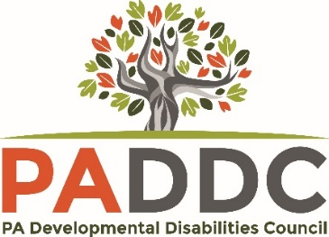

Applicant: _____________________________________________
Address: _____________________________________________________________
Phone number: _______________ Email: _________________________________
Name of Event: _________________________________________
Location of Event: _______________________________________
Date(s) of Event: _______________________________________________________
Name of Individual(s) Attending with You: ____________________________________
Check all applicable boxes:
I am a person with a developmental disability

I am a family member or legal guardian of a person with a developmental disability

I live in Pennsylvania

I am paid to work on a PADDC project

Conference/Event Registration |  |  | $
Travel |  |  | $ | Amount Requested from Council: | $______________
Lodging |  |  | $ | Amount Funded by Another Source: | $______________
Food/Other Expenses |  |  | $
Direct Care/ PAS worker |  |  | $
 | Total |  | $

LEAF Scholarship Pre-Event Questionnaire

- How will attending this event increase your advocacy and knowledge?

- How will this event improve everyday life for you and/or your family?

- How and with who, will you share what you learn, and/or the materials you receive at the event, to help improve their everyday life?

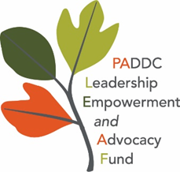
Email Applications to: ra-pwpaddc@pa.gov
Mail Applications to: PADDC LEAF
2330 Vartan Way, Suite 130
Harrisburg, PA 17110

**Please include proof of the event, such as: event flyer, schedule/agenda, registration page and fees, etc. - or tell us in your email where to find these details on the internet.

Signature: ________________________________ Date: _____________________

The Pennsylvania Developmental Disabilities Council is supported by the Administration for Community Living (ACL), U.S. Department of Health and Human Services (HHS) as part of a financial assistance award totaling $3,095,416.00 with 100 percent funding by ACL/HHS. Council efforts are those of the grantee and do not necessarily represent the official views of, nor an endorsement, by ACL/HHS, or the U.S. Government.

