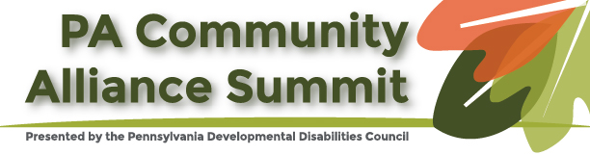

SEEKING SUBJECT MATTER EXPERTS to FACILITATE DISCUSSIONS!

The 2021 Pennsylvania Community Alliance Summit is scheduled for the third week in August 2021 and will be virtual! This year’s theme is: Recover, Rebuild, Reform.

There are many reasons 2020 and 2021 have been stressful and traumatic for some communities, but also transformational and motivating for others. We are seeking experts to provide background information on an important issue impacting their community, and then to facilitate a group discussion to explore how the topic and community intersect. Plan to discuss at least these 3 key things related to your topic:

- What does “recovery” look like in your community?
- How can we “rebuild” communities to move forward?
- What “reform” is needed to improve community systems?

Here are some examples of the topics we are interested in hearing about and discussing:

- Remote education and learning
- Social equity, protest, civil disobedience
- Military experiences or injuries
- Sexual abuse, physical abuse, traumas
- Suicide prevention and intervention
- Job loss, unemployment, minimum wage
- Housing loss, homelessness, shelters
- Pandemic, quarantining, personal protective equipment
- Food and supplies insecurity
- Communities and civil rights movements
- Voting and the 2020 fall election
- Vaccines, health and telemedicine
- National borders, immigration and refugees
- Death, grief, and isolation
- Addiction, abuse, depression
- Physical distancing - remote and virtual interactions.
- Digital divide, broadband access
- Mental and behavioral health
- Disability, accessibility and inclusion
- Policing and the justice system

This list is certainly not exhaustive; feel free to submit ideas for other subjects and diverse marginalized communities to discuss. We welcome presenters/facilitators who are working towards equity and inclusion for all. Complete the proposal submission form below, included with this announcement and submit your application by email.

Applications are due Friday, April 23, 2021. Please submit your application (2nd page below) by email to: danathomps@pa.gov.

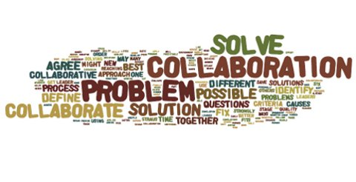

2021 PA Community Alliance Summit Presentation/Facilitation Application
Organization(s):
Main Contact Name:
Main Contact Email Address:
Telephone Number:
- What topic will you present and facilitate on and what community(ies) are associated and experience disparate impacts:

- Name(s) and Job Title(s) of Presenter(s) and/or Facilitator(s):

- Besides the three discussion points identified above (Recover, Rebuild, Reform), what key points will you cover/what things do you think may be discussed by the group?

Your Summary MUST FIT ON THIS ONE PAGE. Do not submit more than this one page!

Please email application to by Friday, April 23, 2021 to Dana Thompson at: danathomps@pa.gov
This event is supported by a grant from the Pennsylvania Developmental Disabilities Council; in part by grant number 1901PASCDD-02, from the U.S. Administration for Community Living, Department of Health and Human Services, Washington, D.C. 20201. Grantees undertaking projects with government sponsorship are encouraged to express freely their findings and conclusions. Points of view or opinions do not, therefore, necessarily represent official ACL policy.

