LEAF Scholarship Pre-conference Questionnaire

- How do you feel attending this event will increase your advocacy, knowledge, or improve everyday life for yourself or your loved one?

- How will this event address one of the Council’s Goals? (System Change, Generic Change, Cross Disabilities, Targeted Disparity, Empowerment, or Stigma)
- How will you share the knowledge and resources with others to help improve their everyday life?
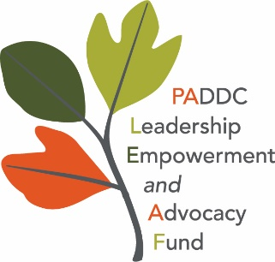
Return questionnaire with scholarship application
to: ra-pwpaddc@pa.gov
Or mail to: PADDC LEAF
2330 Vartan Way, Suite 130
Harrisburg, PA 17110

