Leadership, Empowerment, and Advocacy Fund (LEAF) Scholarship Instructions

Eligibility
In order to be considered for a LEAF scholarship, the following eligibility criteria must be met.

Individual eligibility:
- A resident of Pennsylvania, AND
- An individual with a developmental disability, OR
- A family member of an individual with a developmental disability, OR
- A guardian of an individual with a developmental disability

Event eligibility:
- Training in self-advocacy, leadership, self-determination
- Education that expands your knowledge of rights of individuals with disabilities
- Training that will assist you in accessing services, support, and other assistance
- Parent training and information
- Events that address Council goals outlined in the State Plan

Funding will be prioritized based on the following criteria:
- Individuals who have not received funds in the past
- Events hosted in Pennsylvania
- Conferences/events regarding rare/uncommon conditions

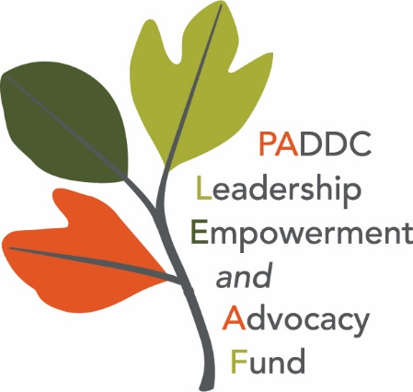
Instructions
LEAF scholarships are available for up to $750 per person, per year. Unless an exception is granted by the Executive Committee, the applicant must arrange and pay for all expenses, then submit for reimbursement after the event. In addition to costs directly associated with the event, such as registration, you may also request assistance with other related expenses such as travel, food, and assistive equipment.

All applications and supporting documents must be submitted no less than 30 days prior to the event. If the conference offers scholarships or stipends, you must apply for those prior to requesting funding through LEAF. PADDC will only award LEAF funds if an applicant is denied a scholarship/stipend through the conference or if there are additional, uncovered expenses. (Please include denial of funding notice with your application). You will be notified by email within 7 days of the approval or denial of your LEAF application.

In order to apply for the LEAF scholarship, you must submit the following documents in order for your application to be considered:

- Scholarship application:
- Please complete the LEAF application.

- Supporting documents:
- Please submit a copy of the conference/event brochure.
- Please complete the pre-conference questionnaire.

General Guidelines for Travel
- Event location must exceed 50 miles from your home to qualify for hotel accommodations
- Mileage reimbursement will be at the Commonwealth rate at the time of the event
- Meal reimbursement will only be covered if the conference doesn’t provide meals and the proper documentation is submitted on the expense report following the event
- Train fare will be reimbursed at the “coach” rate
- Overnight sustenance will be reimbursed at the rate of $30 per day

Expectations Following Event
Applicants who receive a LEAF scholarship are expected to complete the following documents after attending a conference or event, and submit them to ra-pwpaddc@pa.gov within 7 business days (prior to reimbursement of expenses).
- Post Conference Questionnaire
- Evaluation Form
- Expense Report
- Receipts for all expenses (including food if applicable.) Food receipts must be itemized and cannot include alcoholic beverages.

