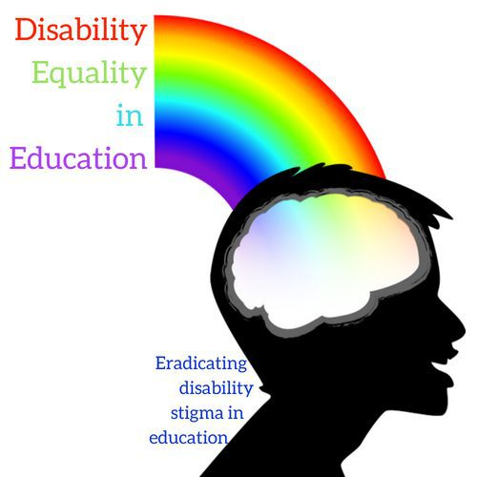
Join our team!

Education Outreach Specialist for Disability Equality in Education

Disabled people are highly encouraged to apply.

- Full time 40 hours a week
- 4 weeks vacation time and major holidays off
- Contract position guaranteed 2 years
- Remote work possible

Disability Equality in Education is supported by the Pennsylvania Developmental Disabilities Council to end the stigma of disabilities in Pennsylvania’s schools and colleges. We are based in Chinatown Philly at Liberty Resources Independent Living Center. Our mission is for kids with disabilities to feel proud and respected and for non-disabled students to become allies of the disability community. Our work centers on themes of disability history, social justice, disability justice and disability pride. This is an exciting opportunity to work in a close knit committed and supportive team with a network of volunteers.

Currently the position is funded for 2 years full time. We will apply for an extension of funding for another year. Funding options are currently being explored to extend the position.

The position is full time 40 hours a week includes travel, overnight stays and occasional weekend work in collaboration and agreement with the Director.
Application deadline is September 16th, 2019
Start date October 1st, 2019 (subject to negotiation)
Shortlisted candidates will need to provide 2 references
Disability Equality in Education is supported by the Pennsylvania Developmental Disabilities Council to end the stigma of disabilities in Pennsylvania’s schools and colleges. We are based in Chinatown Philly at Liberty Resources Independent Living Center. Our mission is for kids with disabilities to feel proud and respected and for non-disabled students to become allies of the disability community. Our work centers on themes of disability history, social justice, disability justice and disability pride. This is an exciting opportunity to work in a close knit committed and supportive team with a network of volunteers.
Education and Experience Qualifications
- Experience working with the disability community or lived experience as a person with a disability.
- Either a B.A. or above in education, psychology or disability studies or in a related field pertinent to the disability community.
- Or a proven track record of experience working in the disability or educational field.
Required Skills
- Excellent written and oral communication skills
- Excellent presentation and workshop facilitation skills
- Experience developing and writing curriculum
- Flexibility and multitasking
- Knowledge of Windows suite and Google suite
- Social media competency
- Work well both independently and as a team
Additional Skills/Experience
- Experience working under a grant
- Event planning
- Business and financial planning
- website design and maintenance
- Knowledge of accessibility in developing presentations
- Graphic design
- Experience in a classroom setting
Please send a resume and cover letter to Alan Holdsworth at adaptdan@yahoo.com

