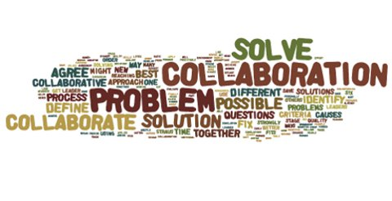
2018 PA Community Alliance Summit Pop-up Presentations Application
Contact Name:
Organization:
Email Address:
Telephone Number:

Please plan for sessions to be no longer than 5 minutes! We anticipate up to 180 people in attendance.
- Title of Pop-up Talk:

- Name(s) of Presenter(s):

- Summary of Session: (What is the topic? Style of session- lecture, discussion w/Q&A, facilitated interactive room discussion, game, other. What key points will you present? What are attendees anticipated to learn? What else would you like us to know?)

Please email application to Dana Thompson at: danathomps@pa.gov Or fax to: (717) 772-0738
This project is supported by the Pennsylvania Developmental Disabilities Council.

